DATA ANALYSIS

Data Table 1: Heterozygous Monohybrid Cross

Flower Color: Purple (dominant - red)
White (recessive - yellow or white)

Pp x Pp
(Red/Yellow) (Red/White)

DATA ANALYSIS

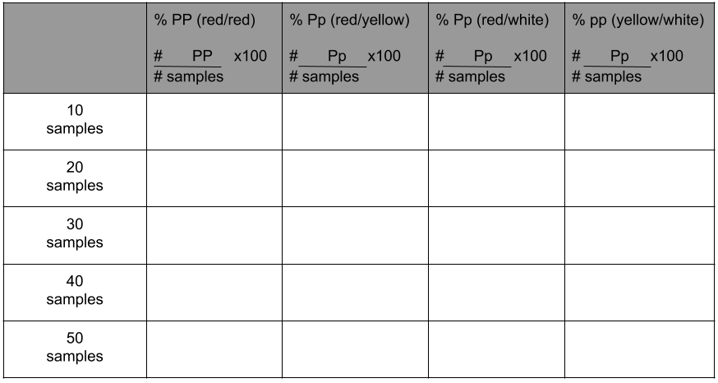

Ideal Genotype

 | PP | Pp | Pp | pp
Percentage | 25% | 25% | 25% | 25%
Ratio | 1 | 1 | 1 | 1

Ideal Phenotype

 | PP | Pp | pp
Percentage | 25% | 50% | 25%
Ratio | 1 | 2 | 1

DATA ANALYSIS

Data Table 2: Heterozygous Dihybrid Cross

Seed Color: Yellow (dominant) Seed Shape: Smooth (dominant)
Green (recessive) Wrinkled (recessive)

Female (clear outer die)
Outer die odd = Y
Outer die even = y
Inner die odd = S
Inner die even = s

Male (colored outer die)
Outer die odd = Y
Outer die even = y
Inner die odd = S
Inner die even = s

YySs x YySs
(Yellow/Smooth) (Yellow/Smooth)

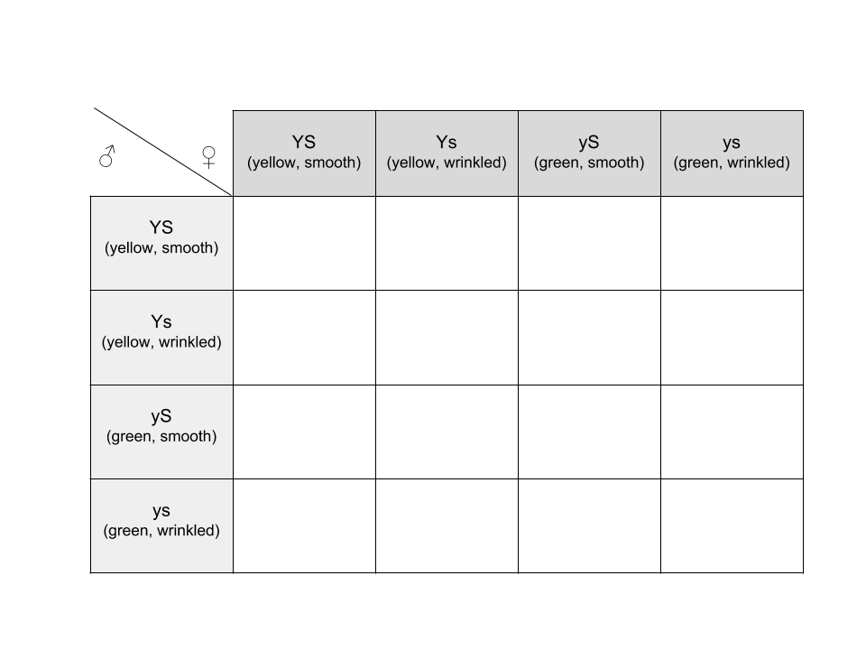
DATA ANALYSIS

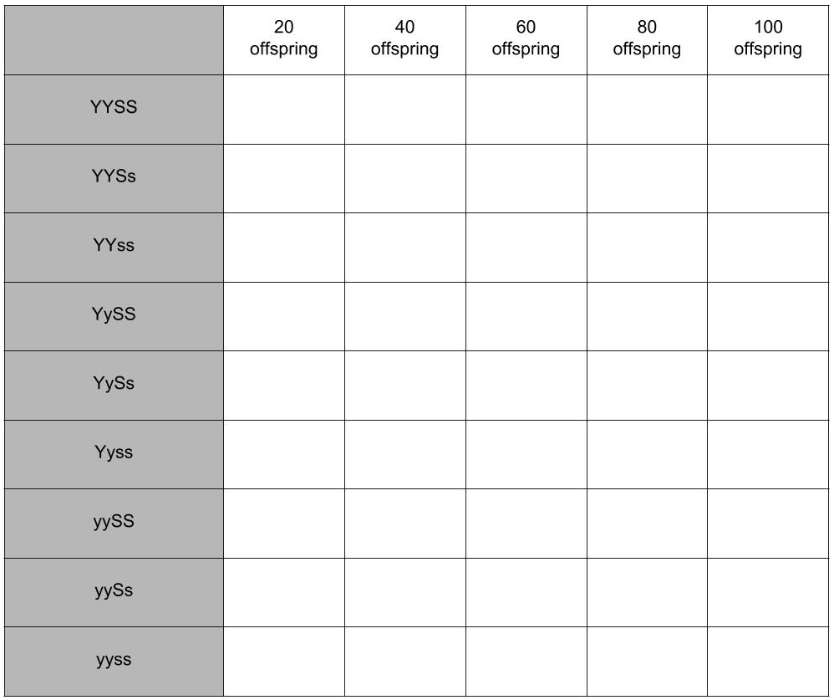

DATA ANALYSIS

Calculate genotype ratios for all sample sets. This can be found by dividing the genotype observed by the number of samples.

Ex: % YYSS = $\frac{\# YYSS}{\# samples}$x 100

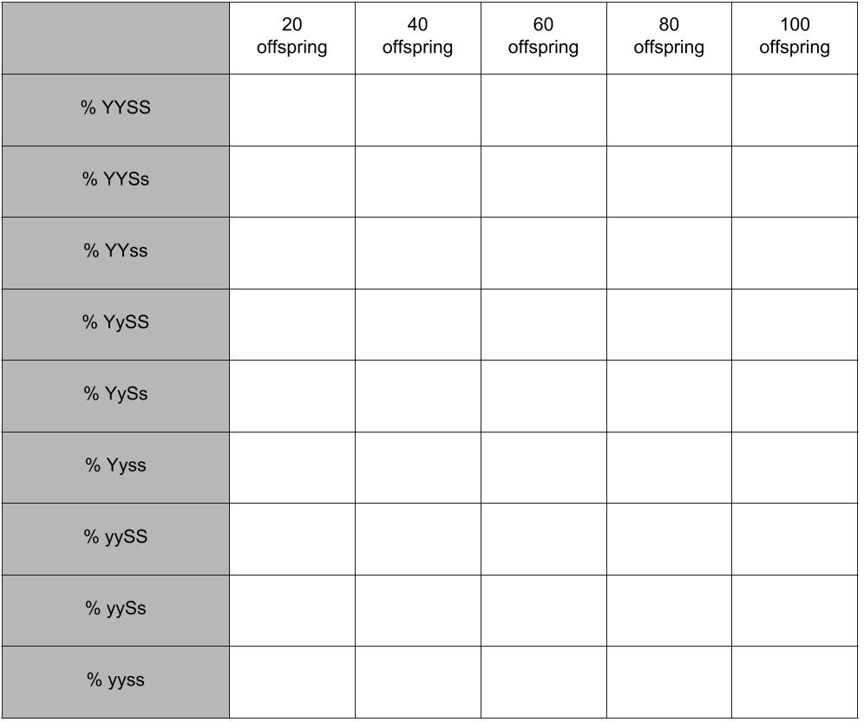

DATA ANALYSIS

Questions

1. How did your data compare to the probable data according to Mendel?

2. Can you tell the genotype of an organism for a particular trait by examining the organism’s phenotype? Explain your answer.

3. If two organisms are dominant for a specific trait and produce an offspring that is recessive for that particular trait, what conclusions can be reached about the genotypes of the parent organisms?

4. If an organism displays a dominant trait, how might it be possible to determine that organism’s genotype?

5. If you were presented with two organisms, each displaying a different phenotype for a particular trait and were given the information that both organisms were homozygous, could you tell which the dominant phenotype was? If not, how could you determine which is dominant?

6. You are given the offspring of a genetic cross to examine. You do not know the phenotypes of the parent organisms that produced that offspring. After examination, it is determined that all offspring are dominant for a specific trait. Is it possible to determine the genotype of one or both parent organisms from this information assuming the offspring conform to probable genetic ratios?

7. Given the same scenario as in the previous question, can the phenotype of both parent organisms be determined by examining the offspring?

8. In this activity, the phenotypes of the characteristics discussed have been discreet. In other words, the characteristics were inherited in a manner in which the offspring displayed either one phenotype or another phenotype. Two of the principles of genetics not discussed in this activity are the principle of incomplete dominance and the principle of codominance. Using any available resources, research one of these principles and describe it below and give an example of the principle as well.

